SIT 111 COMPUTER SYSTEMS
TASK 3.4p: Arduino Control using Sensors
Summary:
In this task I worked with a software called Arduino uno. This task focused on writing a code and the objective was to build and understand a basic Arduino circuit that uses a sensor to collect data readings . The materials I required were
- arduino Uno (or similar Arduino board)
• Soil Moisture Sensor
• Breadboard
• Jumper wires
• USB cable to connect the Arduino to a computer
• Arduino IDE installed on the computer
Personal summary :
I followed the sample circuit picture on the task sheet and formed the circuit in the same way. For this task the code was already provided so initially we worked on that as it aligned with my previous learning experiences as well so it was easy to understand the code. We included a new library called DHT.h and connected the digital pin to the DHT sensor, added the if loop and then compiled, verified and ran the code.

Module summary:
Introduction to storing sensor data:
Storing sensor data is critical in numerous applications, including environmental monitoring, scientific research, and industrial automation. Arduino can be a powerful tool for collecting and recording data from sensors. External Storage Devices: Arduino can interface with various external storage devices like SD cards, EEPROM and even cloud-based services for data storage.
Data logging methods:
Data logging is the process of collecting data from sensors or other sources and storing it for future analysis. Some techniques of data logging are:
- continuous logging:
this method involves regularly recording data at predefined intervals, making it suitable for applications like environmental monitoring, where we need to track changes in conditions overtime.

- Event based logging :
We use event based logging in Arduino when we want to capture data only when certain events occur. For example we log sensor data when a motion detector detects movement or when a threshold value is exceeded.
CONNECTING AND READING DATA FROM COMMON SENSORS:
Understanding sensors:
Sesnors are essential components in the world of electronics and automation and play a pivotal role in detecting and quantifying a wide range of physical properties in the environment. These properties encompass crucial factors such as temperature, humidity, light levels, distance, etc.

TEMPERATURE SENSOR LIKE DHT22:
Temperature and humidity sensors, like the DHT22, are widely utilized for measuring ambient temperature and relative humidity levels. These sensors find extensive applications in climate control, weather monitoring, and environmental data collection due to their precision and reliability.

SOIL MOISTURE SENSOR:
The Soil Moisture Sensor, serves as an essential component for monitoring soil moisture levels. This sensor is particularly valuable in agricultural applications, garden automation, and environmental sensing.
We can connect a Soil Moisture Sensor to your Arduino and collect data on soil moisture for various purposes, such as automated watering systems or soil health monitoring.

ADVANCED SENSOR INTEGRATION:
INTERFERING WITH MORE ADVANCED SENSORS:
ADVANCED SENSORS:
These sensors offer greater precision and can measure a wider range of physical properties. + Ultrasonic Sensor (e.g., HC-SR04): Measures distance via ultrasonic waves, suitable for obstacle avoidance in robotics and precise distance measurement. + IR Sensor (e.g., IR Receiver Module): Detects infrared signals, ideal for remote control applications, infrared communication, and automation systems. For example: Distance-Dependent LED Indicator with Ultrasonic Sensor.

Learning journey :
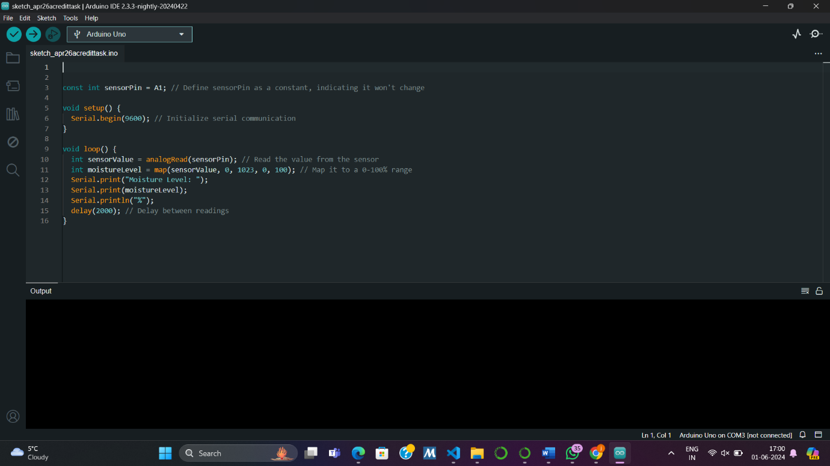

Reflections :
How do you know you have achieved the learning goals?
I learned about the basic commands and some new ways to use Arduino in this task and also got familiar with the usage of Arduino uno. Got my hands on compiling the circuit and knowing about the components. This was my first time working with a sensor and I found it quite interesting .
• What is the most important thing you learned from this and why?
The key takeaway is learning how to integrate sensors with an Arduino for data collection and logging. This is essential for creating automated systems in various fields, such as environmental monitoring and agriculture.
• How does the content or skills learned here relate to things you already know?
This builds on my existing knowledge of electronics and programming, enhancing my skills by introducing sensor integration and data logging techniques.
• Where or when do you think it will be useful?
These skills are useful for:
- Automated irrigation in agriculture
- Climate control systems
- Environmental data collection
- Industrial automation
- DIY electronics projects

Youtube video link: https://youtu.be/tPK0XsgOdf4

